EXPERIMENT NO. 12: INSUREEASY ONLINE INSURANCE MANAGEMENT PLATFORM
AIM:
To construct the InsureEasy online insurance portal enabling customers to compare health/auto/home insurance policies, calculate dynamic premiums, manage policy renewals, and allow agents and admins to review policy applications and dispatch SMS alerts.
PSEUDOCODE (IN 6 SIMPLE POINTS):
Step 1: Define insurance policy tiers across Life, Health, Auto, and Home insurance with base rates and coverage multipliers.
Step 2: Provide interactive comparison slider to adjust coverage amount and policy term, calculating annual and monthly premiums.
Step 3: Enable customers to submit digital insurance proposal applications with nominee and vehicle/health declaration details.
Step 4: Display an active policyholder dashboard with policy numbers, maturity dates, and payment history.
Step 5: Implement an automated renewal alert module that calculates days remaining before policy lapse and triggers SMS alerts.
Step 6: Provide administrator and agent portals to approve pending policy proposals and inspect customer portfolios.
SOURCE CODE:
<!DOCTYPE html>
<html lang="en">
<head>
<meta charset="UTF-8">
<title>InsureEasy - Online Insurance Portal</title>
<style>
body { font-family: 'Segoe UI', Tahoma, sans-serif; margin: 0; background: #f1f5f9; color: #1e293b; }
header { background: #1e3a8a; color: white; padding: 20px 35px; display: flex; justify-content: space-between; align-items: center; }
.container { max-width: 950px; margin: 25px auto; background: white; padding: 25px; border-radius: 8px; box-shadow: 0 4px 12px rgba(0,0,0,0.06); }
.calc-box { background: #eff6ff; border: 1px solid #bfdbfe; padding: 20px; border-radius: 8px; margin-bottom: 25px; }
.grid-2 { display: grid; grid-template-columns: 1fr 1fr; gap: 15px; margin-bottom: 15px; }
select, input, button { width: 100%; padding: 10px; border: 1px solid #cbd5e1; border-radius: 6px; box-sizing: border-box; }
button { background: #1e3a8a; color: white; font-weight: bold; border: none; cursor: pointer; }
button:hover { background: #172554; }
.policy-card { border: 1px solid #e2e8f0; border-radius: 8px; padding: 18px; margin-top: 15px; display: flex; justify-content: space-between; align-items: center; }
.sms-alert { background: #fef3c7; border-left: 5px solid #d97706; padding: 12px; margin-top: 20px; border-radius: 4px; }
</style>
</head>
<body>
<header>
<h2>InsureEasy Global Portal</h2>
<span>Role: Policyholder / Agent</span>
</header>
<div class="container">
<h3>Instant Insurance Policy Premium Calculator</h3>
<div class="calc-box">
<div class="grid-2">
<div>
<label>Insurance Category:</label>
<select id="insCategory" onchange="computePremium()">
<option value="Health">Comprehensive Health Cover (Cashless)</option>
<option value="Auto">Motor Vehicle Comprehensive Policy</option>
<option value="TermLife">Term Life Protection Plan</option>
</select>
</div>
<div>
<label>Applicant Age:</label>
<input type="number" id="applicantAge" value="28" oninput="computePremium()">
</div>
</div>
<div class="grid-2">
<div>
<label>Coverage Sum Assured:</label>
<select id="sumAssured" onchange="computePremium()">
<option value="500000">Rs. 5,00,000</option>
<option value="1000000" selected>Rs. 10,00,000</option>
<option value="2500000">Rs. 25,00,000</option>
</select>
</div>
<div>
<label>Estimated Annual Premium:</label>
<div style="font-size: 22px; font-weight: bold; color: #1e3a8a; margin-top: 6px;">Rs. <span id="premiumAmount">7,500</span> / year</div>
</div>
</div>
<button onclick="applyPolicy()">Apply for Policy</button>
</div>
<div id="applicationResult"></div>
<hr style="margin: 30px 0;">
<h3>Policyholder Portfolio & SMS Renewal Alerts</h3>
<div class="policy-card">
<div>
<h4 style="margin:0; color:#1e3a8a;">Policy No: POL-772910 [Health Care Protect]</h4>
<p style="margin:4px 0; color:#64748b;">Insured: Rahul Sharma | Sum Assured: Rs. 10,00,000</p>
<small>Premium Due Date: 15-Nov-2026</small>
</div>
<button onclick="sendRenewalSms('POL-772910', 'Rahul Sharma')" style="width: auto; padding: 8px 16px; background:#d97706;">Trigger Renewal SMS</button>
</div>
<div id="smsOutput"></div>
</div>
<script>
function computePremium() {
let cat = document.getElementById('insCategory').value;
let age = parseInt(document.getElementById('applicantAge').value) || 25;
let sum = parseInt(document.getElementById('sumAssured').value);
let rate = (cat === 'Health') ? 0.0075 : (cat === 'Auto' ? 0.012 : 0.005);
let ageFactor = age > 40 ? 1.4 : 1.0;
let premium = Math.round(sum * rate * ageFactor);
document.getElementById('premiumAmount').innerText = premium.toLocaleString();
}
function applyPolicy() {
let cat = document.getElementById('insCategory').value;
let prem = document.getElementById('premiumAmount').innerText;
let polNo = 'POL-' + Math.floor(100000 + Math.random() * 900000);
document.getElementById('applicationResult').innerHTML = `
<div style="background:#dcfce7; color:#166534; padding:15px; border-radius:6px; margin-top:15px;">
<h4>Policy Application Approved!</h4>
<p><b>Policy Number:</b> ${polNo} | <b>Plan:</b> ${cat} Insurance | <b>Annual Premium:</b> Rs. ${prem}</p>
<small>Official policy document and digital certificate have been emailed to your account.</small>
</div>`;
}
function sendRenewalSms(pol, name) {
document.getElementById('smsOutput').innerHTML = `
<div class="sms-alert">
<b>SMS Notification Dispatched:</b> "Dear ${name}, your policy ${pol} is due for renewal on 15-Nov-2026. Pay premium before due date to avoid policy lapse. Team InsureEasy."
</div>`;
}
</script>
</body>
</html>
Output:
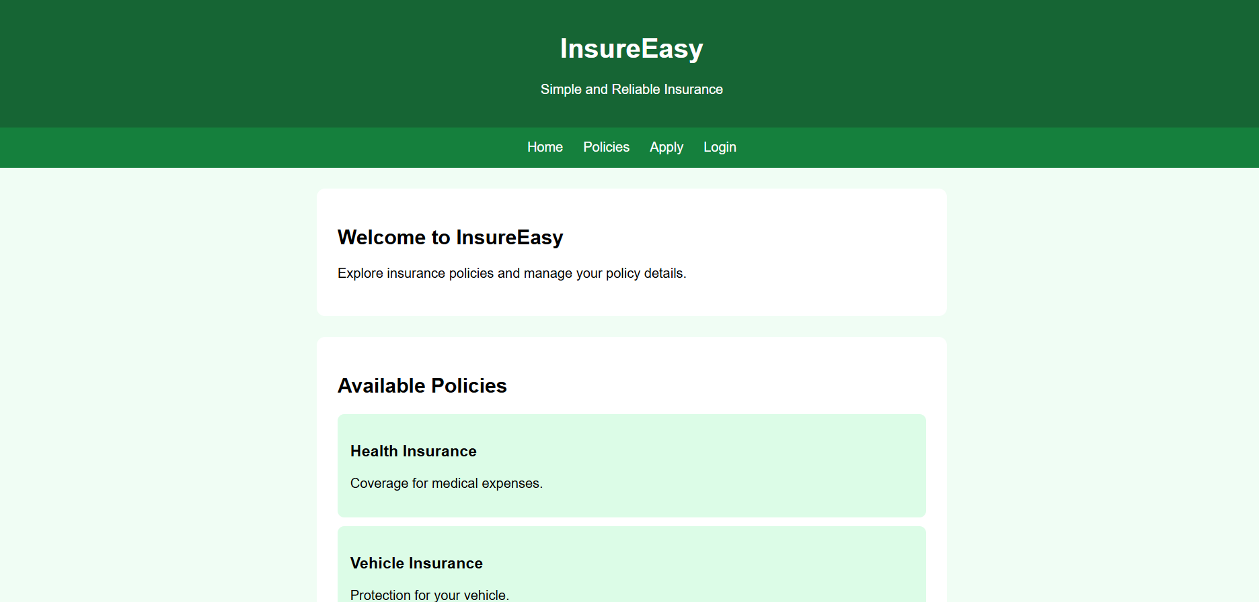
RESULT:
Thus, the InsureEasy online insurance management platform was successfully developed and tested, providing real-time premium calculations, policy applications, policyholder portfolio tracking, and automated SMS renewal alerts.

